**To verify an email address**

1. Sign in to the AWS Management Console and open the Amazon SES console at <https://console.aws.amazon.com/ses>.
2. In the navigation pane, under **Verified Senders**, click **Email Addresses**.
3. Click **Verify a New Email Address**.
4. In the **Verify a New Email Address** dialog box, type your email address in the indicated field, and then click **Verify This Email Address**.

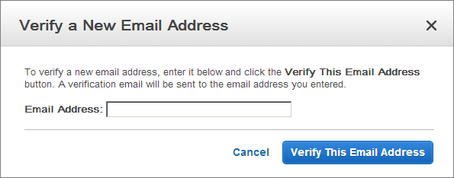

1. In your email client, open the message from Amazon SES asking you to confirm that you are the owner of this email address.
2. Click the link in the message.

**Note**

The link in the verification message expires 24 hours after your original verification request.

1. The status of the email address in the Amazon SES console will change from "pending verification" to "verified".
2. You can now use Amazon SES to send email from this address. To send a test email, check the box next to the verified email address, and then click **Send a Test Email**.

**To view your verified email addresses**

1. Sign in to the AWS Management Console and open the Amazon SES console at <https://console.aws.amazon.com/ses>.
2. In the navigation pane, under **Verified Senders**, click **Email Addresses**.
3. In the list of verified email addresses, you can expand one or more email addresses to view the details.